ST. MARY of SORROW'S
KNIGHTS OF COLUMBUS
SCHOLARSHIP

2017 APPLICATION

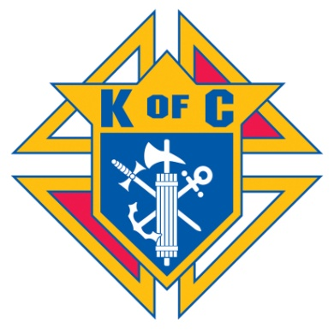

St. Mary of Sorrows Knights of Columbus Council #8600 is pleased to announce we are offering up to nine (9) $750 scholarships. Applicants must be registered members of St. Mary of Sorrows Parish or a son, daughter, grandchild, or spouse of a wife of Council #8600. Scholarships are to be used for tuition only and are to pursue post-secondary school education.

Applications and related materials must be received not later than May 1st, 2017 to be considered. Please mail applications and related materials to:

Knights of Columbus #8600
Scholarship Committee
P.O. Box 339
Fairfax Station, VA 22039

PRIVACY ACT ADVISORY STATEMENT

The Privacy Act of 1974 (P.L. 93.579) requires that you be given certain information in connection with this request for data. Pursuant to the requirements of the Act, please be advised:

1. The authority for the collection of this data is Public Law 93-642.
2. Submitting the information requested is voluntary.
3. The main purpose for which the data will be used is the selection of award winners for the Knights of Columbus Council #8600 Scholarships.
4. Other routine uses of the data are for public affairs and press releases to news media.
5. Failure to complete the form will mean that you cannot be included among those candidates being considered for this scholarship award.

I. BIOGRAPHICAL QUESTIONAIRE

The following questions are designed to collect information about your background, your interests and your plans. Answers to these questions will be used in connection with your application for this scholarship award and will be made available to the Scholarship Selection Committee.

General Information (Please Type or Print)

1. ______________________________________________________________________
Applicant’s Full Name: Last, First, Middle Marital Status

2. _______________________________________________________________________
Date of birth: Month, Day, Year SSN Last Four Sex

3. _______________________________________________________________________
Permanent Home Address and Telephone Number

4.________________________________________________________________________
Father, Step-father, or legal guardian: last, first, middle

5.________________________________________________________________________
Mother, step-mother, or legal guardian: last, first, middle

6. ________________________________________________________________________
College or University you will attend. (include address, state, zip, area code/telephone no.)

Signature of Applicant: ____________________________________Date: ___________
II. This section is to be completed by the Applicant.

1. Involvement in civic and/or religious activities. Indicate the activity, date(s) of your direct, active involvement, and your role or actions.

2. Participation in extracurricular school activities. Indicate the activity, date(s) of your active participation and describe your role in the activity.

3. Describe any circumstances, if any, which you believe have impacted on your grades. Please have you school forward an Official Transcript of your high school and/or college grades to the Knights of Columbus #8600, Scholarship Committee, c/o Fred Walker, 10843 Broadwater Drive, Fairfax, VA, 22032.

Signature:________________________________________Date:___________________

III. To be completed by the Applicant’s Parent, Guardian, or Other Individual selected by the Applicant. In the space below, please describe the Applicant’s outstanding or inspirational contributions. Please limit your response to 250 words or less.

Signature:____________________________________________________Date:__________

